Types of Objects
# Source: AI Source: Provided by: [Data Path: Persons Table -> ID Column: 1, Name_En Column: Motasem Essam] -> From: [Chatgpt (GPT-4-turbo)] on [8/4/2025]
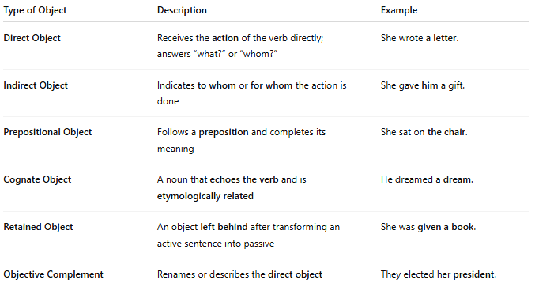

Type of Object | Description | Example
Direct Object | Receives the action of the verb directly; answers “what?” or “whom?” | She wrote a letter.
Indirect Object | Indicates to whom or for whom the action is done | She gave him a gift.
Prepositional Object | Follows a preposition and completes its meaning | She sat on the chair.
Cognate Object | A noun that echoes the verb and is etymologically related | He dreamed a dream.
Retained Object | An object left behind after transforming an active sentence into passive | She was given a book.
Objective Complement | Renames or describes the direct object | They elected her president.

